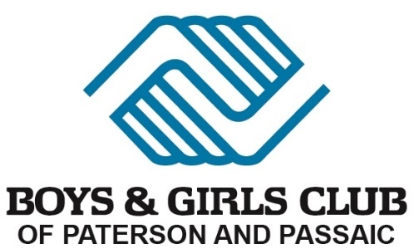

NO REFUND POLICY

Thank you for choosing The Boys and Girls Club of Paterson and Passaic Aquatics Program as your destination for swim lessons.
Due to the nature of the services, all Aquatic services offered through the Boys and Girls Club of Paterson and Passaic are non-refundable under any circumstances.
For any further clarification with regards to our No Refund Policy Please reach out to us directly via email: Jbracho@bgcppnj.org.

